# Монитор Активности

Все мы прекрасно знаем , что по каждый запуск 1с создается сеанс на кластере серверов 1С. Каждый сеанс , при ображению к MS SQL создает соединение. Соединения группируются в рабочие Процессы Кластера 1с (rphost) . Для работы со скулем вам понадобится мэнеджмент студия (скачать можно здесь <https://docs.microsoft.com/ru-ru/sql/ssms/download-sql-server-management-studio-ssms?view=sql-server-2017> )

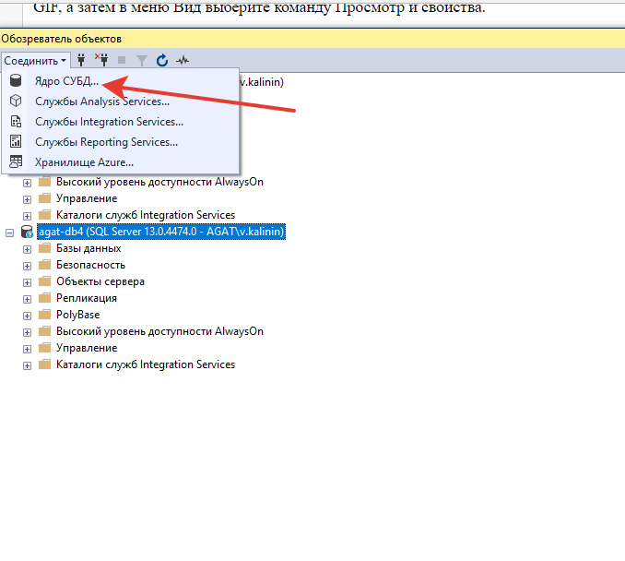

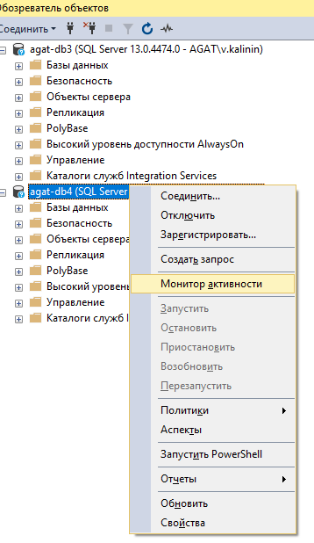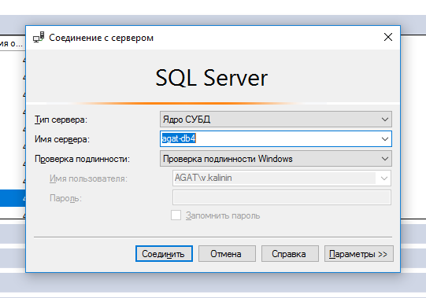В консольке нажимаем «Содинить» -Ядро СУБД. Логинемся под собой

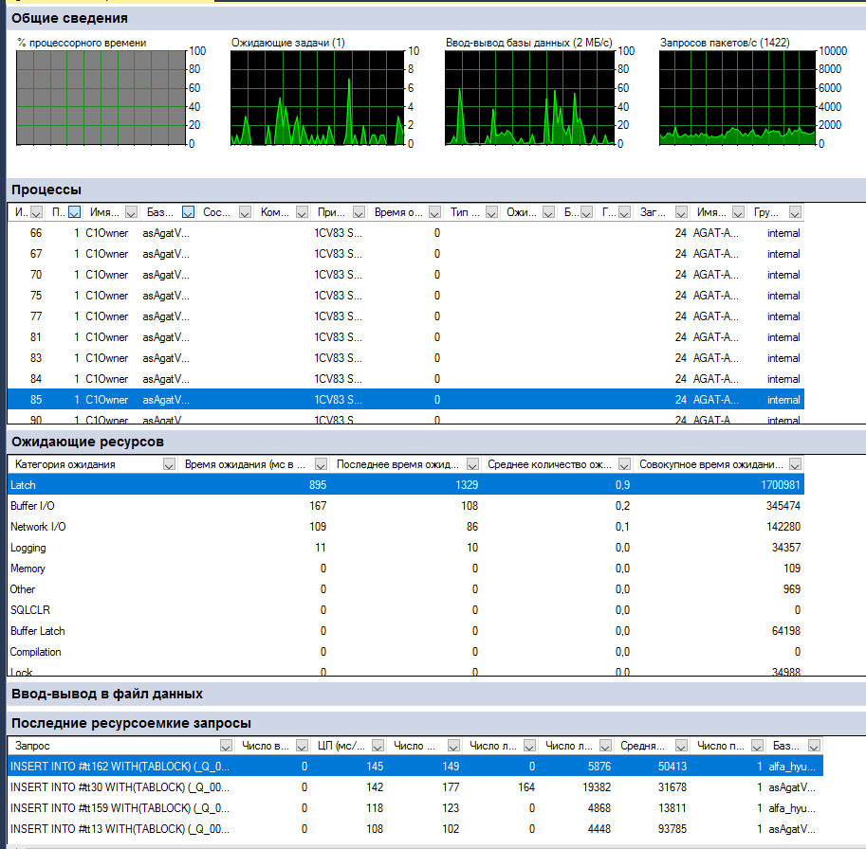Правой кнопкой и выбираем монитор активности. На данном мониторе изображены несколько вкладок . В часточти нас интересуют вкладка процессы

Можно кликнуть на поле база и отобрать процессы в интересуемой нас базе.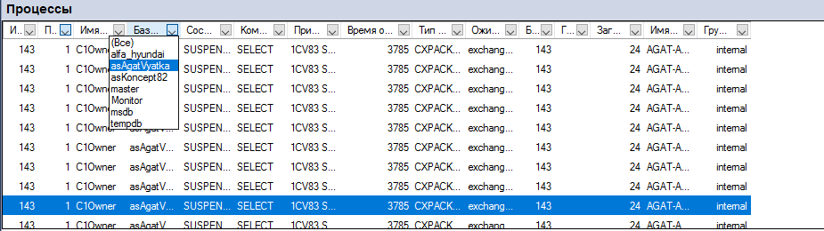

Для того ,чтобы завершить процесс , необходимо на него кликнуть и нажать «Завершить процесс».

# Как Узнать активные запросы

В форме обозревателя правой кнопкой на сервер и выбираем создать запрос . Пишем

exec sp_whoIsActive

И выполняем, в результате вернутся все актуальные запросы.

# Немного полезных скриптов

1. Убить все процессы

USE [master];

DECLARE @kill varchar(8000) = '';

SELECT @kill = @kill + 'kill ' + CONVERT(varchar(5), session_id) + ';'

FROM sys.dm_exec_sessions

WHERE database_id = db_id('asKoncept82')

EXEC(@kill);

1. Узнать размер таблиц

SELECT

t.NAME AS TableName,

s.Name AS SchemaName,

p.rows AS RowCounts,

SUM(a.total_pages) * 8 AS TotalSpaceKB,

SUM(a.used_pages) * 8 AS UsedSpaceKB,

(SUM(a.total_pages) - SUM(a.used_pages)) * 8 AS UnusedSpaceKB

FROM

sys.tables t

INNER JOIN

sys.indexes i ON t.OBJECT_ID = i.object_id

INNER JOIN

sys.partitions p ON i.object_id = p.OBJECT_ID AND i.index_id = p.index_id

INNER JOIN

sys.allocation_units a ON p.partition_id = a.container_id

LEFT OUTER JOIN

sys.schemas s ON t.schema_id = s.schema_id

WHERE

t.NAME NOT LIKE 'dt%'

AND t.is_ms_shipped = 0

AND i.OBJECT_ID > 255

GROUP BY

t.Name, s.Name, p.Rows

ORDER BY

t.Name

1. Ресурсоемкие запросы за 1 час (можно изменить интервал параметра)

DECLARE @StartTime datetime;

DECLARE @EndTime datetime;

Set @StartTime = DATEADD(hour,-1,GETDATE());

Set @EndTime = GETDATE();

select

top 1000

creation_time,

last_execution_time,

execution_count,

total_worker_time/1000 as CPU,

convert(money, (total_worker_time))/(execution_count*1000)as [AvgCPUTime],

qs.total_elapsed_time/1000 as TotDuration,

convert(money, (qs.total_elapsed_time))/(execution_count*1000)as [AvgDur],

total_logical_reads as [Reads],

total_logical_writes as [Writes],

total_logical_reads+total_logical_writes as [AggIO],

convert(money, (total_logical_reads+total_logical_writes)/(execution_count + 0.0))as [AvgIO],

case

when sql_handle IS NULL then ' '

else(substring(st.text,(qs.statement_start_offset+2)/2,(

case

when qs.statement_end_offset =-1 then len(convert(nvarchar(MAX),st.text))*2

else qs.statement_end_offset

end - qs.statement_start_offset)/2 ))

end as query_text,

db_name(st.dbid)as database_name,

object_schema_name(st.objectid, st.dbid)+'.'+object_name(st.objectid, st.dbid) as object_name

from sys.dm_exec_query_stats qs

cross apply sys.dm_exec_sql_text(plan_handle) st

where total_logical_reads > 0 AND last_execution_time > @StartTime AND last_execution_time < @EndTime

order by AvgIO desc

1. Текущие ожидания скуля

WITH [Waits] AS

(SELECT

[wait_type],

[wait_time_ms] / 1000.0 AS [WaitS],

([wait_time_ms] - [signal_wait_time_ms]) / 1000.0 AS [ResourceS],

[signal_wait_time_ms] / 1000.0 AS [SignalS],

[waiting_tasks_count] AS [WaitCount],

100.0 * [wait_time_ms] / SUM ([wait_time_ms]) OVER() AS [Percentage],

ROW_NUMBER() OVER(ORDER BY [wait_time_ms] DESC) AS [RowNum]

FROM sys.dm_os_wait_stats

WHERE [wait_type] NOT IN (

N'BROKER_EVENTHANDLER', N'BROKER_RECEIVE_WAITFOR',

N'BROKER_TASK_STOP', N'BROKER_TO_FLUSH',

N'BROKER_TRANSMITTER', N'CHECKPOINT_QUEUE',

N'CHKPT', N'CLR_AUTO_EVENT',

N'CLR_MANUAL_EVENT', N'CLR_SEMAPHORE',

-- Maybe uncomment these four if you have mirroring issues

N'DBMIRROR_DBM_EVENT', N'DBMIRROR_EVENTS_QUEUE',

N'DBMIRROR_WORKER_QUEUE', N'DBMIRRORING_CMD',

N'DIRTY_PAGE_POLL', N'DISPATCHER_QUEUE_SEMAPHORE',

N'EXECSYNC', N'FSAGENT',

N'FT_IFTS_SCHEDULER_IDLE_WAIT', N'FT_IFTSHC_MUTEX',

-- Maybe uncomment these six if you have AG issues

N'HADR_CLUSAPI_CALL', N'HADR_FILESTREAM_IOMGR_IOCOMPLETION',

N'HADR_LOGCAPTURE_WAIT', N'HADR_NOTIFICATION_DEQUEUE',

N'HADR_TIMER_TASK', N'HADR_WORK_QUEUE',

N'KSOURCE_WAKEUP', N'LAZYWRITER_SLEEP',

N'LOGMGR_QUEUE', N'MEMORY_ALLOCATION_EXT',

N'ONDEMAND_TASK_QUEUE',

N'PREEMPTIVE_XE_GETTARGETSTATE',

N'PWAIT_ALL_COMPONENTS_INITIALIZED',

N'PWAIT_DIRECTLOGCONSUMER_GETNEXT',

N'QDS_PERSIST_TASK_MAIN_LOOP_SLEEP', N'QDS_ASYNC_QUEUE',

N'QDS_CLEANUP_STALE_QUERIES_TASK_MAIN_LOOP_SLEEP',

N'QDS_SHUTDOWN_QUEUE', N'REDO_THREAD_PENDING_WORK',

N'REQUEST_FOR_DEADLOCK_SEARCH', N'RESOURCE_QUEUE',

N'SERVER_IDLE_CHECK', N'SLEEP_BPOOL_FLUSH',

N'SLEEP_DBSTARTUP', N'SLEEP_DCOMSTARTUP',

N'SLEEP_MASTERDBREADY', N'SLEEP_MASTERMDREADY',

N'SLEEP_MASTERUPGRADED', N'SLEEP_MSDBSTARTUP',

N'SLEEP_SYSTEMTASK', N'SLEEP_TASK',

N'SLEEP_TEMPDBSTARTUP', N'SNI_HTTP_ACCEPT',

N'SP_SERVER_DIAGNOSTICS_SLEEP', N'SQLTRACE_BUFFER_FLUSH',

N'SQLTRACE_INCREMENTAL_FLUSH_SLEEP',

N'SQLTRACE_WAIT_ENTRIES', N'WAIT_FOR_RESULTS',

N'WAITFOR', N'WAITFOR_TASKSHUTDOWN',

N'WAIT_XTP_RECOVERY',

N'WAIT_XTP_HOST_WAIT', N'WAIT_XTP_OFFLINE_CKPT_NEW_LOG',

N'WAIT_XTP_CKPT_CLOSE', N'XE_DISPATCHER_JOIN',

N'XE_DISPATCHER_WAIT', N'XE_TIMER_EVENT')

AND [waiting_tasks_count] > 0

)

SELECT

MAX ([W1].[wait_type]) AS [WaitType],

CAST (MAX ([W1].[WaitS]) AS DECIMAL (16,2)) AS [Wait_S],

CAST (MAX ([W1].[ResourceS]) AS DECIMAL (16,2)) AS [Resource_S],

CAST (MAX ([W1].[SignalS]) AS DECIMAL (16,2)) AS [Signal_S],

MAX ([W1].[WaitCount]) AS [WaitCount],

CAST (MAX ([W1].[Percentage]) AS DECIMAL (5,2)) AS [Percentage],

CAST ((MAX ([W1].[WaitS]) / MAX ([W1].[WaitCount])) AS DECIMAL (16,4)) AS [AvgWait_S],

CAST ((MAX ([W1].[ResourceS]) / MAX ([W1].[WaitCount])) AS DECIMAL (16,4)) AS [AvgRes_S],

CAST ((MAX ([W1].[SignalS]) / MAX ([W1].[WaitCount])) AS DECIMAL (16,4)) AS [AvgSig_S],

CAST ('https://www.sqlskills.com/help/waits/' + MAX ([W1].[wait_type]) as XML) AS [Help/Info URL]

FROM [Waits] AS [W1]

INNER JOIN [Waits] AS [W2]

ON [W2].[RowNum] <= [W1].[RowNum]

GROUP BY [W1].[RowNum]

HAVING SUM ([W2].[Percentage]) - MAX( [W1].[Percentage] ) < 95; -- percentage threshold

GO